Unit 2 – Number Sense
Properties of Real Numbers, Powers of Base Ten, Scientific Notation, “Perfect” Square Roots, Perfect Squares, Ordering and Comparing Fractions/Decimals/Percents/Scientific Notation, Identify and describe absolute value for rational numbers
Key Vocabulary
- Absolute Value: ________________________________________________________________________________________________________________________________________________________________________
- Exponent: ________________________________________________________________________________________________________________________________________________________________________
- Percent: _______________________________________________________________________________________________________________________________________________________________________
- Rational Number: ________________________________________________________________________________________________________________________________________________________________________
- Perfect Square: ________________________________________________________________________________________________________________________________________________________________________
- Scientific Notation:
________________________________________________________________________________________________________________________________________________________________________
- Square Root: ________________________________________________________________________________________________________________________________________________________________________
- Additive Identity Property (Identity Property of Addition): ________________________________________________________________________________________________________________________________________________________________________
- Additive inverse property (Inverse Property of Addition): ________________________________________________________________________________________________________________________________________________________________________
- Associative property of Addition: ________________________________________________________________________________________________________________________________________________________________________
- Associative property of Multiplication: ________________________________________________________________________________________________________________________________________________________________________
- Commutative Property of Addition: ________________________________________________________________________________________________________________________________________________________________________
- Commutative Property of Multiplication: ________________________________________________________________________________________________________________________________________________________________________
- Distributive Property: ________________________________________________________________________________________________________________________________________________________________________
- Multiplicative Identity Property (Identity Property of Multiplication): ________________________________________________________________________________________________________________________________________________________________________
- Multiplicative Inverse Property (Inverse Property of Multiplication):
________________________________________________________________________________________________________________________________________________________________________
- Multiplicative Property of Zero: ________________________________________________________________________________________________________________________________________________________________________
Properties of Real Numbers
Match the appropriate Property with the correct example.  _____ 1. 4 + 5 + 6 = 6 + 4 + 5  _____ 2. a(0) = 0  _____ 3. 2 (½) = 1  _____ 4. (a)(d)=(d)(a)  _____ 5. (8+2)+4 = 8+(2+4)  _____ 6. 8(1) = 8  _____ 7. 42 – 6a = 6(7-a)  _____ 8. a + 0 = a | a. additive identity  b. commutative of addition  c. associative of addition  d. multiplicative inverse  e. multiplicative identity  f. commutative of multiplication  g. distributive property  h. associative of multiplication  i. multiplicative of zero

Name the property shown by each statement:

9. 17 + 22 = 22 + 17

10. 12 x 46 = 46 x 12

11. 89 + 0 = 89

12. 89 x 1 = 89

13. 89 x 0 = 0

14. (8 + 4) + 5 = 8 + (4 + 5)

15. (43 x 2) x 5 = 43 x (2 x 5) _____________

Powers of Base Ten
Express the following powers of ten in standard form.
1) 10⁴ =
2) 10⁷ =
3) 10¹⁷ =
4) 10⁻¹ =
5) 10⁻⁴ =
6) 10⁻¹² =

Express the following numbers as powers of ten.
7) 10 =
8) 100,000 =
9) 1,000,000,000,000,000,000 =
10) 0.001 =
11) 1 =
12) 0.000000001 =

Scientific Notation
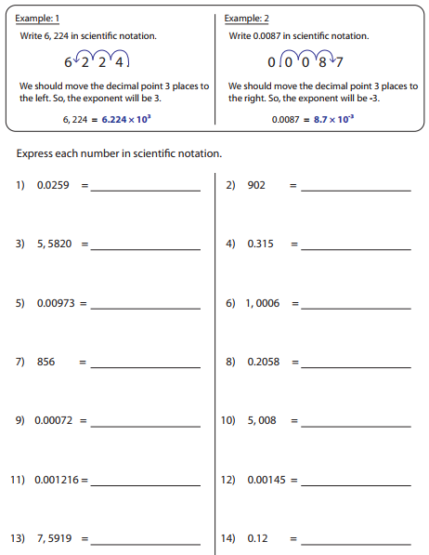

Perfect Squares and Square Roots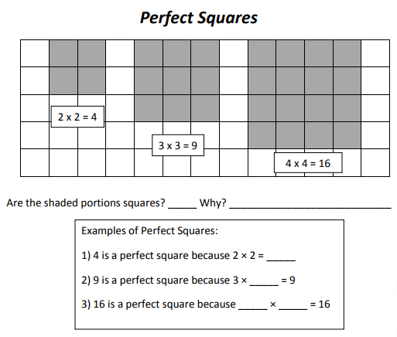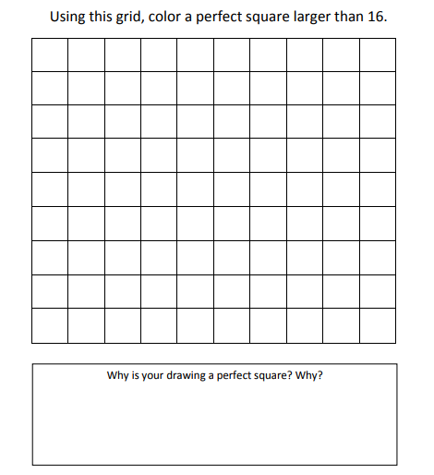
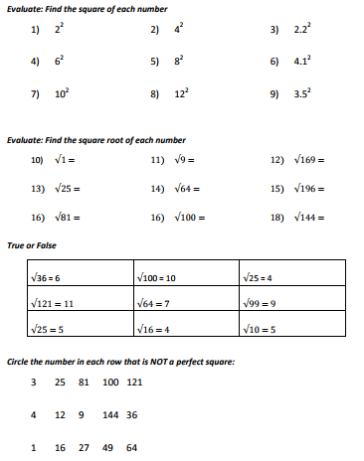
Rational Numbers for Rational Numbers
- $\left|-2\right|$

- $\left|-6.8\right|$

- $-\left|-109\right|$

- $\left|-\frac{5}{6}\right|$

- $\left|\frac{3}{4}\right|$

- $-\left|103.25\right|$

- $\left|471.378\right|$
Questions to Ask the Teacher!

