Unit 6: Proportional Reasoning
Grade 7 Proportional Reasoning

- Is there always only one correct way to solve a problem? Explain.

- Jessica thinks $\frac{4}{5}$ = $\frac{7}{8}$. She says these are equal because $4+3 = 7$, and $5+3=8$. Write an explanation to convince her she has made a mistake in thinking. You may use words, pictures, and numbers to support your idea.

- Are these two ratios equivalent: $\frac{3}{4}$ = $\frac{4.5}{6}$ ? Why or why not? Use words, pictures or numbers to explain your thinking.

- Name a situation in the real world that involves proportions (equal ratios).

- Three students have different reasons for why these two ratios are equal: $\frac{2}{6}$ = $\frac{4}{12}$ For each answer, tell whether you think this method will work for other ratios too.
  - Silas - looking across the numerators, I noticed that $2 × 2 =4$, and in the denominators I noticed $6×2 =12$.
  - Deshawn – if you look at each ratio separately, both of the bottom numbers are 3 times the number on the top.
  - Marcus – if you multiply the diagonal numbers, you get the same answer. $6x4 = 24$, and $2x12=24$.

- Which of the following proportions will correctly solve this problem?
A car can travel 22 miles on 1 gallon of gas.
How many gallons will it take to drive 200 miles?
$\frac{22}{1}$ = $\frac{x}{200}$ | $\frac{22}{1}$ = $\frac{200}{x}$
$\frac{1}{22}$ = $\frac{x}{200}$ | $\frac{22}{200}$ = $\frac{1}{x}$

- Maria is making a scale map of her neighborhood. In real life, her street is 2 kilometers long (that’s 2,000 meters). She wants to use a scale of 1:500 to draw her map. Do you think this is reasonable? Why or why not? How long will the street need to be on the map?

- Ariana has $10 in her pocket. She sees some earrings at the mall that she really likes. The price tag says $15, but there is a sign that says 40% off. Will Ariana have enough money to buy the earrings?

Grade 8 Proportional Problems

- If you pay 5 percent sales tax on four items, have you paid a total of 20 percent sales tax? Why or why not?

- You find a pair of jeans on a clearance rack that originally cost $64. They were marked down 50%. The clearance price sign says an additional 50% off. Johnny says that you do not need to pay anything for the jeans. Do you agree? Why or Why not?

- Batty Baseball is having a sale of 30% off all bats. If Easton bats sell for $59.99, what is the amount of the discount? If I have $50 in my wallet, can I buy an Easton bat with a 5 percent sales tax? Show your thinking and calculations.

- Jack and Jill conducted a survey of the students in their science class. They found out the following information: 75 percent of the students in the class do their homework three or more nights each week. Of the students who do homework three or more nights a week, half do homework five nights each week. From the information given, can you tell how many students are in the class? Explain why or why not.

- A bicycle store is planning a special event. The owner wants to advertise that bikes are 25% off, but doesn’t want to lose money from his regular prices. One employee suggests first doing a 25% markup of all the prices, then offering 25% off to bring the prices back to the regular amount. Will this plan work? Why or why not? Give an example of how one bike price would be affected to support your answer.

- Ella is designing a model of the Great Pyramid of Giza. Her model has a scale of in. = 7.5 ft. Her model is 25 in. long. Explain how you can find the length of the Great Pyramid.
(The School District of Manatee County Florida)

- An adult dog gets one teaspoon of vitamins per 20 lbs of its body weight. Explain how to determine what dosage to give an adult dog that weighs 15 lbs.
(The School District of Manatee County Florida)

- VDOE Released SOL Item #7 (Spring, 2014)
Dora bought a total of 48 cupcakes. Each cupcake cost $0.55, including tax. Of the cupcakes she bought, $\frac{3}{8}$ were vanilla cupcakes. What was the total cost of only the vanilla cupcakes?
A $26.40
B $16.50
C $9.90
D $6.60

- A dress at Forever 13 usually sells for $28.00. If the dress is 40% off, and sales tax is 5%, what is the total price of the jacket, including tax?

- Jocelyn earns $9.25 an hour working at the local bakery. If she works on a holiday, she earns triple this hourly rate for each hour she works. What is the amount of her paycheck after taxes if she works 32 regular hours and 5 hours on Thanksgiving?

- Rezia’s checkbook had a balance of $822.05 on March 1. On March 5, she wrote a check for $116.70 at the grocery store. On March 7, she wrote a check in the amount of $520.00 for rent. On March 9, her dad sent her $105.00 to deposit into her account. What is the balance of Rezia’s account after this deposit?

- Jamie wants to earn $500 in interest so she’ll have enough to buy a used car. She puts $2000 into an account that earns 2½% interest. How long will she need to leave her money in the account to earn $500 in interest?
- Kelly plans to put her graduation money into an account and leave it there for 4 years while she goes to college. She receives $750 in graduation money that she puts into an account that earns 4.25% interest. How much will be in Kelly’s account at the end of four years?

- Deena earned $76,000 the first year she was employed as a systems engineer. The second year, she earned 30% more. If she donated 12% of her gross income from the two years to a local charity, how much did she donate?

- The local food bank has started its semi-annual food drive. In support, local grocery stores have advertised a sale on canned soup. Three different brands of soup are available in large quantities. Yummy in Your Tummy soup is being sold at $18.89 for 12 cans of 284 ml. Canned Creations soup is being sold at $30.69 for 24 cans of 284 ml.

  - Which is the better deal between these two brands?
  - Super Soup is being sold at $60.99 for 24 larger cans of 568 ml. Which is the better deal now?
  - If the school raises $200 to buy for the food bank, what is the most soup they could buy?

- VDOE Suggested Practice Item on page 8 (Spring, 2012)
Jonah buys lunch each day from the school cafeteria. In September, Jonah spent $45.00 on school lunches. In October, he spent $51.75 on school lunches.
- What is the percent increase in the amount of money Jonah spent on school lunches in October compared to the amount of money he spent in September?
- When compared to October, Jonah had a 10% increase in school lunch spending in November. How much did he spend on school lunches in November?

VDOE Released SOL Item #4 (Spring, 2014)
- A food company reduced the amount of salt in one of their food products from 700 milligrams to 630 milligrams. What is the percent decrease in the amount of salt in this food product?
A 10%
B 12%
C 70%
D 90%

Problem solving with algebraic equations

- Beatrice has 18 pencils. Beatrice has 2 more than 4 times the number of pencils Rick has. Exactly how many pencils does Rick have?
Rick has 4 pencils.
NOTE: This question can be adjusted to include asking for students to write the equation first then solve.)
- The sum of a number and –13 is –7. Write an equation then solve for the number.
$$x+\left(-13\right)= -7; x=6$$

- John called a plumber to fix a leak in his bathroom. The plumber charged $30 to come to the house and $25 an hour while fixing the leak. If the final bill was $105, write an equation and solve to find how many hours the plumber was at John’s house.
30 + 25x = 105, x = 3. The plumber was at John’s house for 3 hours.

- Brittany is $\frac{1}{4}$Caroline’s age. If Brittany is 2 years old, what is Caroline’s age?
2 = $\frac{1}{4}c$ ; Caroline is 8 years old.

- Ginger spent $24 at the fair, which was three times the amount she spent last year at the fair. How much money did Ginger spend last year at the fair?
24 = 3y ; y = 8, so Ginger spent $8 last year.

Similar Figures

- Police and surveillance companies use similarity to determine the height of robbers caught on videotape. How do they do this?

You may want to use pictures or a video as an example. Police can approximate the height of robbers by comparing them to similarly-sized items.

- I drew seven triangles. Five were similar to one another, three were congruent, and two were neither similar nor congruent to any other. What might these triangles have looked like? Draw the triangles and label their side lengths.

One example:
Student may come to realize congruent shapes are also similar.

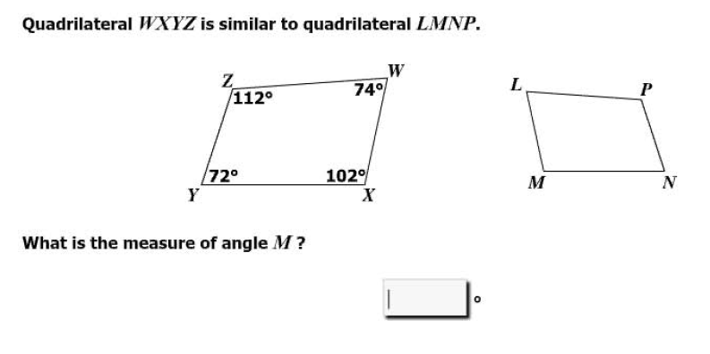

- Triangle JKL is similar to triangle PQR.
Which three proportions can be used to find the value of x?
J
K
L
8
10
6
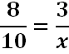
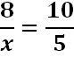
Q
5
x
3
P
R
A. B.

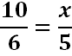
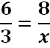
C. D.

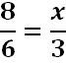
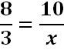
E. F.
A, C, F

